

Practices for Secure Software Report

Table of Contents
Document Revision History 3
Client 3
Instructions 3
Developer 4
1. Algorithm Cipher 4
2. Certificate Generation 4
3. Deploy Cipher 4
4. Secure Communications 4
5. Secondary Testing 4
6. Functional Testing 4
7. Summary 4
8. Industry Standard Best Practices 4

Document Revision History

Version | Date | Author | Comments
1.0 | 2/22/2026 | Jacob Garrett | Finalized customer proposal, and the use case UML and activity UML diagrams.

Client



Instructions

Submit this completed practices for secure software report. Replace the bracketed text with the relevant information. You must document your process for writing secure communications and refactoring code that complies with software security testing protocols.

- Respond to the steps outlined below and include your findings.
- Respond using your own words. You may also choose to include images or supporting materials. If you include them, make certain to insert them in all the relevant locations in the document.
- Refer to the Project Two Guidelines and Rubric for more detailed instructions about each section of the template.

Developer
Jacob Garrett

Algorithm Cipher

To address Artemis Financial’s requirement for secure file verification and enhanced protection of client financial data, I recommend implementing the Secure Hash Algorithm 256-bit variant (SHA-256). SHA-256 is part of the SHA-2 family developed by the National Institute of Standards and Technology and is widely adopted as an industry-standard cryptographic hash function. Because Artemis Financial requires a checksum mechanism to verify data integrity during transmission, SHA-256 is appropriate due to its strong collision resistance and proven reliability in financial and government systems.

At a high level, SHA-256 is a one-way hash function that converts input data of any size into a fixed 256-bit (32-byte) output known as a digest. This digest uniquely represents the original data, and even a minor change in input produces a completely different hash value. Unlike encryption algorithms, SHA-256 is not reversible, which makes it ideal for verifying data integrity rather than encrypting confidential information.

The 256-bit output provides strong protection against collision attacks, meaning it is computationally infeasible for two different inputs to produce the same hash. SHA-256 can also be used within secure communication frameworks such as HTTPS, where asymmetric cryptography (e.g., RSA) and symmetric session keys rely on secure random number generation during TLS handshakes. While SHA-256 itself does not use keys, it supports secure protocols and can be combined with symmetric keys in HMAC implementations for authentication.

Historically, earlier algorithms such as MD5 and SHA-1 became vulnerable to collision attacks, prompting the adoption of the SHA-2 family in 2001. Today, SHA-256 remains secure, efficient, and recommended for integrity verification. Its continued acceptance in financial and enterprise systems makes it a sound and standards-aligned choice for Artemis Financial’s modernization efforts.

Certificate Generation
Insert a screenshot below of the CER file.

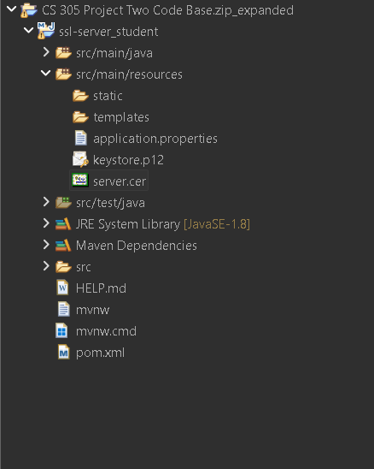

Deploy Cipher
Insert a screenshot below of the checksum verification.

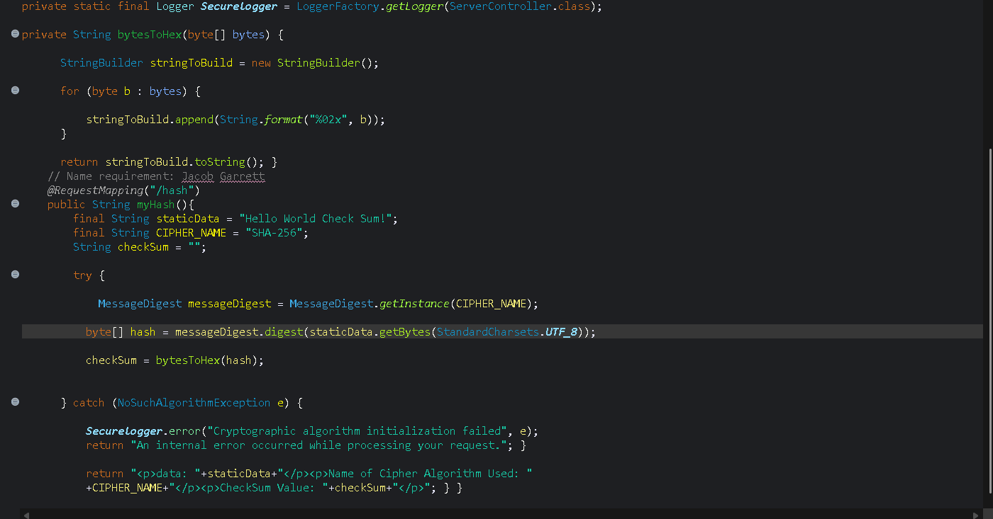

Secure Communications
Insert a screenshot below of the web browser that shows a secure webpage.

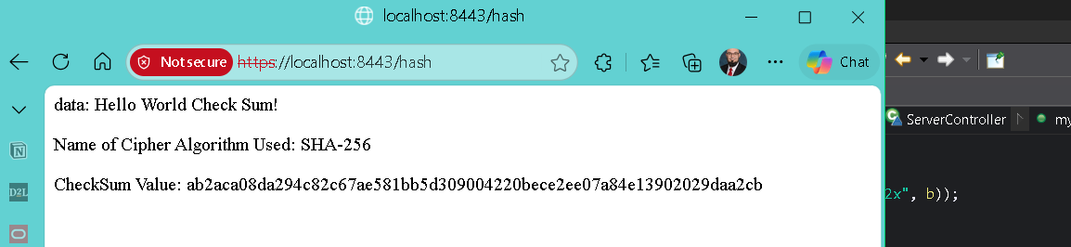

Secondary Testing
Insert screenshots below of the refactored code executed without errors and the dependency-check report.

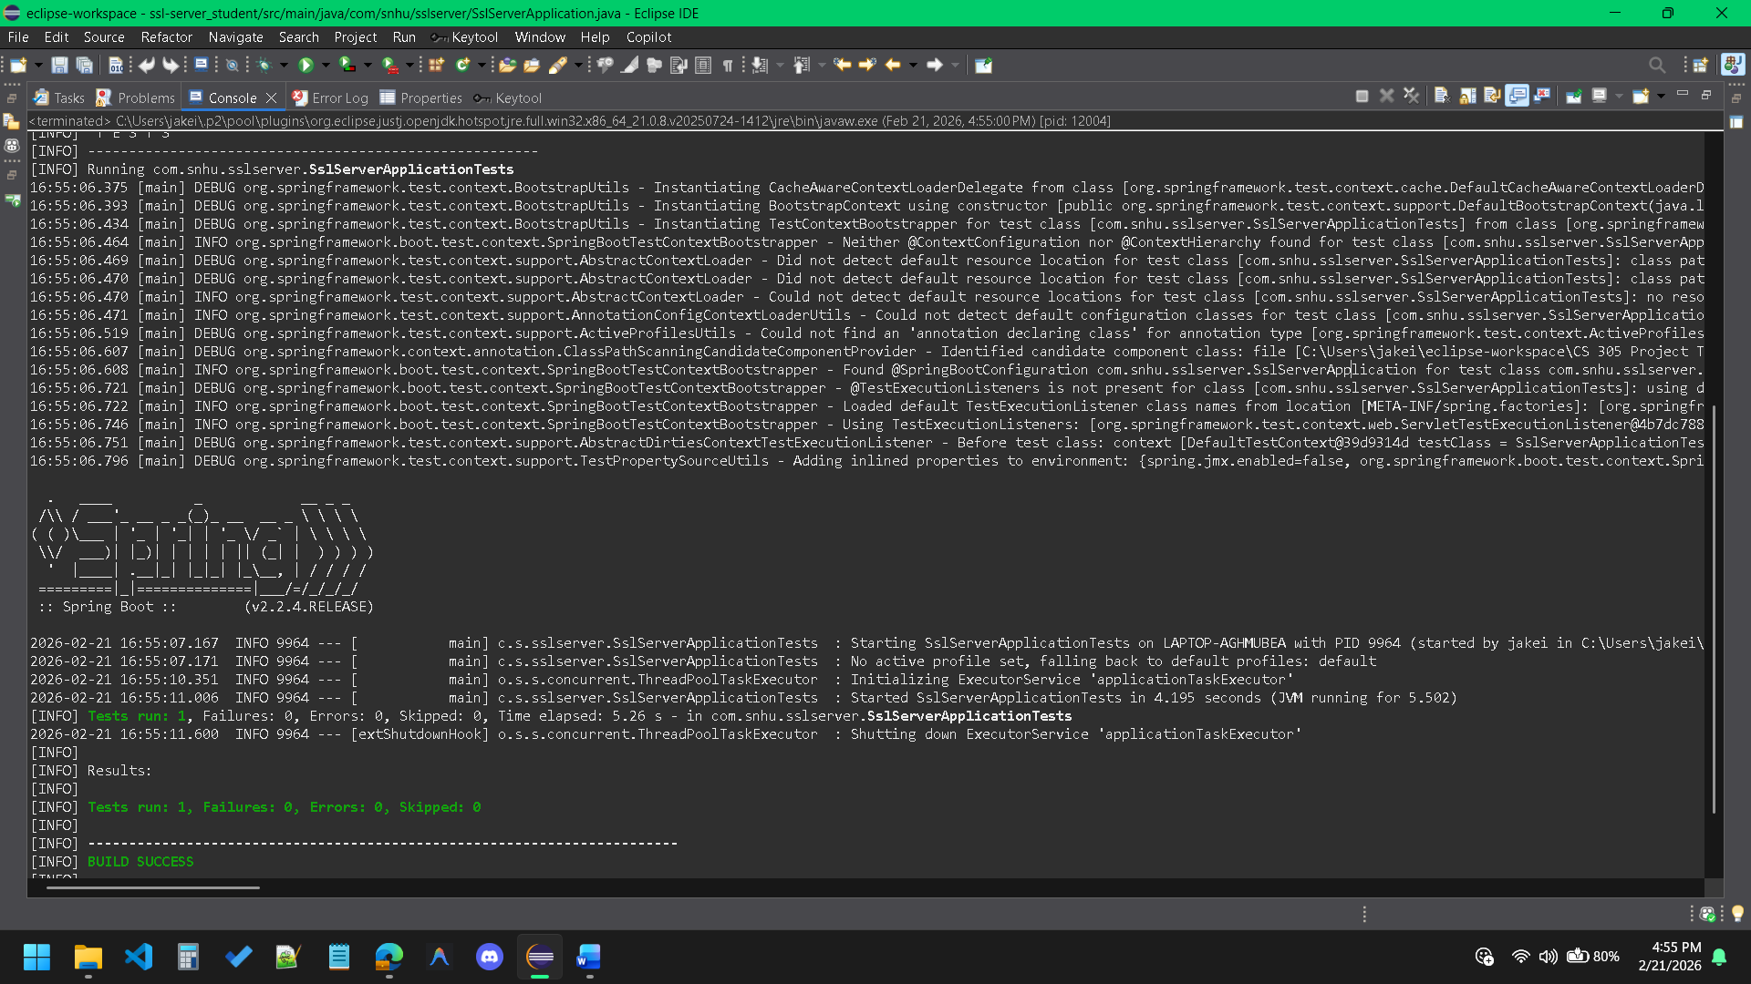

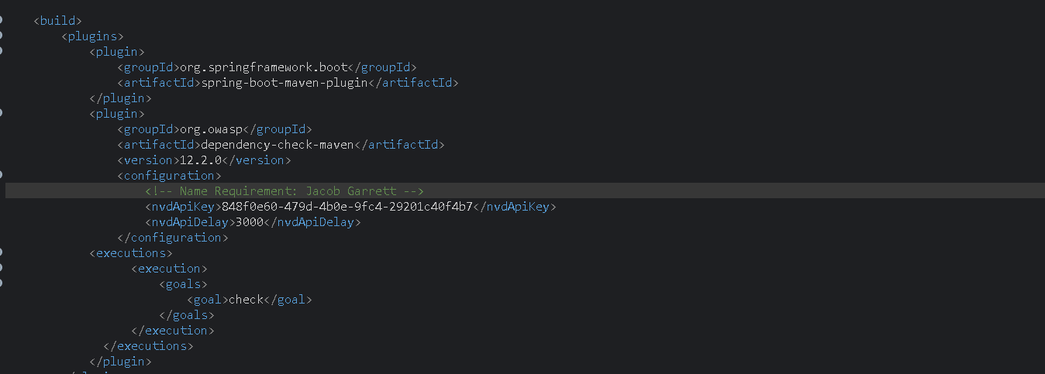

Functional Testing
Insert a screenshot below of the refactored code executed without errors.

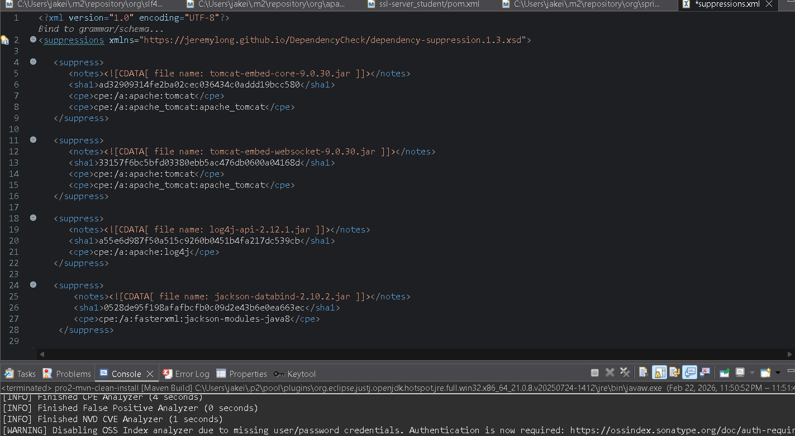

Summary

The software application underwent strategic architectural refactoring to ensure strict compliance with modern security testing protocols and to remediate critical flaws identified during the static analysis phase. The primary refactoring effort centered on the Project Object Model configuration, targeting the mitigation of high severity vulnerabilities within the application layer.

Referring to the vulnerability assessment process flow diagram, the remediation phase specifically addressed data integrity and component isolation. By elevating the dependency framework versions, specifically updating the Spring Boot parent directive and patching the Jackson Data Processor modules to secure semantic versions, the application is now fortified against Extensible Markup Language External Entity injections and untrusted data deserialization exploits. The refactoring process stripped away outdated libraries that permitted unauthorized entity expansion, replacing them with validated components that enforce strict data parsing boundaries.

The procedure for integrating layers of security into the software application followed a defense in depth methodology, requiring the execution of the following sequential steps:

Analytical Validation: The initial step required the configuration of dependency suppression parameters within the Extensible Markup Language definitions to isolate true vulnerabilities from scanner misclassifications, ensuring targeted remediation.

Component Upgrades: The second step involved iterating the central framework version within the Project Object Model. This forced the dependency resolution engine to automatically fetch secured transitive libraries, structurally resolving aggregate vulnerabilities without introducing code conflicts.

Data Parsing Restrictions: The third step established runtime security by manually defining the secure iteration of the jackson-databind dependency to version 2.6.7.4. This specific layer prevents external entity expansion during Document Object Model deserialization, actively neutralizing data exfiltration vectors.

Validation and Synchronization: The final step required executing a clean build cycle to purge local caches, synchronize the secure artifacts from the remote repository, and execute a secondary vulnerability scan to verify the integrity of the updated dependency tree.

Industry Standard Best Practices

Industry standard best practices for secure coding were systematically applied to mitigate the known vulnerabilities and fortify the overall application architecture. Specifically, the principle of utilizing secure and up to date components was executed. Rather than attempting to manually patch third party source code, the project utilized centralized package management to update vulnerable libraries, such as the Jackson Databind package, to their officially patched iterations. This approach effectively closed known attack vectors, such as CVE-2020-25649, while maintaining framework integrity.

To maintain the software application’s existing security baseline during this process, the refactoring utilized scoped dependency updates and strict adherence to semantic versioning. By upgrading to the patched releases within the same major version branch, the existing application programming interfaces remained undisturbed. This practice ensures that the mitigation of security flaws does not introduce breaking changes or operational regressions into the established production environment. Furthermore, the implementation of a continuous dependency verification pipeline ensures that future integrations are automatically evaluated against national vulnerability catalogs.

The value of applying these industry standard best practices for secure coding extends far beyond the immediate software artifact; it is foundational to the company’s overall operational well-being. Proactive vulnerability remediation prevents catastrophic data breaches, directly safeguarding proprietary intellectual property and sensitive consumer data. From a fiscal perspective, integrating security into the development lifecycle significantly reduces technical debt and minimizes the exponential costs associated with emergency incident response protocols. Ultimately, adherence to these rigorous standards ensures compliance with regulatory data protection mandates, thereby protecting the corporate reputation, maintaining stakeholder trust, and ensuring long term financial stability.

